**ISSUES DOCUMENT**

**WHAT ISSUES I FACED**

1. First issue I faced was integrating Google Maps. I had learnt a lot from these tutorials;

<http://www.tutorialspoint.com/android/android_google_maps.htm> and <https://developers.google.com/maps/documentation/android-api/map>

<http://code.tutsplus.com/tutorials/getting-started-with-google-maps-for-android-basics--cms-24635>

These really helped me a lot. I had to make sure that latest version of SDK was installed and everything is set up properly.

1. In the same google maps issues, when creating a new place, the pointer marker won’t move upwards easily, sometimes it does and sometimes it doesn’t (not even in the extended control option where I can manually input the co-ordinates) and instead the whole page moves upward. (May be I have done something wrong with layout screen or IDK).

Only if I pinch zoom to that location in advance I’m able to place the marker.

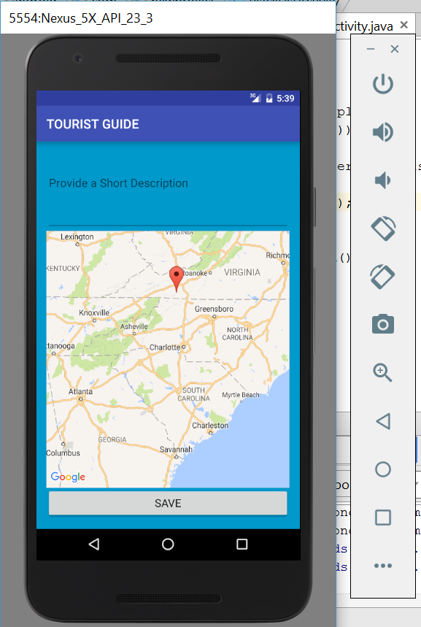

**WHAT WAS NOT IMPLEMENTED**

* I couldn’t implement just the Google Analytics. There was lot to do with location service, SQL and Maps so I didn’t have enough time. I was also concentrating on making the app work faster and improving the UI**.**

**WHAT WORKS PERFECTLY**

* Everything works good, the registration page, success message, Login page, Loading Google maps, location service, creating new places, find the places that are created and database storing and retrieving too.
* As far as now I didn’t see any lags but only once my app stopped working (just once) and that’s because I didn’t give permission to the app for location service. The accelerometer also works fine. I forgot to show that in the video but here it is:

